**Unit-1: Theoretical Frame Work**

**• An Introduction: Meaning of Accountancy, book-keeping and Accounting, Accounting**

**Process , Objectives for accounting, Differences between book-keeping and accounting,**

**Users of accounting information , Limitations of Accounting , Basic terminologies**

**Unit-1: Theoretical Framework**

**1. Introduction to Accounting**

**Meaning of Accountancy, Book-keeping, and Accounting**

**(a) Accountancy**

* Accountancy refers to the systematic knowledge of accounting principles and techniques.
* It includes the methods used to record, classify, and analyze financial transactions.
* It is broader than accounting as it involves the entire body of theoretical and practical knowledge related to financial record-keeping and reporting.

**(b) Book-keeping**

* Book-keeping is the process of systematically recording financial transactions in books of accounts.
* It is the first step in the accounting process and involves maintaining ledgers, journals, and trial balances.
* It does not involve interpreting financial data.

**(c) Accounting**

* Accounting is the process of recording, summarizing, analyzing, and interpreting financial transactions.
* It helps businesses understand their financial position and performance.
* It includes book-keeping but extends to reporting, decision-making, and financial analysis.

| **Basis** | **Book-keeping** | **Accounting** |
| --- | --- | --- |
| **Scope** | Limited to recording transactions | Includes recording, summarizing, and analyzing |
| **Objective** | To maintain systematic records | To determine financial position and performance |
| **Nature** | Routine and clerical | Analytical and interpretative |
| **Decision-Making** | No role | Helps in decision-making |

**2. Accounting Process**

The accounting process consists of the following sequential steps:

1. **Identifying Transactions** – Recognizing financial transactions that need to be recorded.
2. **Recording** – Entering financial transactions in books (journals, ledgers).
3. **Classifying** – Organizing transactions into relevant categories (assets, liabilities, revenues, expenses).
4. **Summarizing** – Preparing financial statements like the trial balance, profit & loss account, and balance sheet.
5. **Analyzing & Interpreting** – Examining financial statements to derive meaningful insights for decision-making.
6. **Communicating Results** – Presenting financial reports to stakeholders like investors, managers, and regulatory bodies.

**3. Objectives of Accounting**

1. **Systematic Record Keeping** – To maintain accurate and systematic financial records.
2. **Financial Performance Assessment** – To determine profits and losses through financial statements.
3. **Financial Position Evaluation** – To analyze assets, liabilities, and equity.
4. **Decision-Making Assistance** – To provide financial data to support business decisions.
5. **Legal Compliance** – To ensure adherence to tax laws and financial regulations.
6. **Facilitating Comparisons** – To compare financial data over different periods or with competitors.

**4. Differences between Book-keeping and Accounting**

| **Aspect** | **Book-keeping** | **Accounting** |
| --- | --- | --- |
| **Definition** | Recording of financial transactions | Recording, classifying, analyzing, and interpreting financial data |
| **Scope** | Narrow, only involves transaction entry | Broad, includes analysis and reporting |
| **Decision-Making** | No role in decision-making | Helps in business decisions |
| **Financial Statements** | Not prepared | Prepared to show financial performance |

**5. Users of Accounting Information**

Accounting information is used by various stakeholders for different purposes:

**(a) Internal Users**

1. **Owners** – To assess profitability and financial stability.
2. **Management** – To make strategic and operational decisions.
3. **Employees** – To understand the financial health of the company, affecting job security and benefits.

**(b) External Users**

1. **Investors** – To decide on investments based on financial performance.
2. **Creditors & Lenders** – To evaluate a company’s ability to repay debts.
3. **Government & Regulatory Bodies** – To ensure tax compliance and adherence to financial regulations.
4. **Customers** – To assess the stability of suppliers.

**6. Limitations of Accounting**

Despite its significance, accounting has certain limitations:

1. **Based on Historical Data** – Accounting records past events, which may not always be relevant for future decisions.
2. **Ignores Qualitative Aspects** – It does not account for non-monetary factors like employee satisfaction or brand reputation.
3. **Subjectivity in Valuation** – Some financial elements (e.g., goodwill, depreciation) involve estimations and judgments.
4. **Affected by Accounting Policies** – Different accounting methods can lead to variations in financial results.
5. **Not Free from Errors or Fraud** – Accounting records can be manipulated, leading to misleading information.

**7. Basic Terminologies in Accounting**

1. **Asset** – Resources owned by a business (e.g., cash, buildings, machinery).
2. **Liability** – Obligations the business needs to pay (e.g., loans, creditors).
3. **Capital** – Owner’s investment in the business.
4. **Revenue** – Income earned from business activities.
5. **Expense** – Costs incurred in generating revenue.
6. **Profit & Loss** – Difference between revenues and expenses.
7. **Ledger** – A book where financial transactions are classified.
8. **Journal** – The book of original entries where transactions are recorded first.
9. **Trial Balance** – A statement that ensures the accuracy of ledger accounts.
10. **Balance Sheet** – A statement showing the financial position of a company at a specific date.

**Conclusion**

Accounting is the backbone of financial decision-making in any organization. It goes beyond simple record-keeping to provide insights into a business’s financial health, helping stakeholders make informed decisions. However, it has limitations, mainly due to its reliance on historical data and subjective judgments. Understanding basic accounting terminologies and principles is crucial for financial literacy in any professional field.

**Accounting Concepts, Principles, Bases and Policies Structure: Accounting Concepts,**

**Principles, Policies and Standards, Types of accounting concepts, Accounting Principles,**

**Accounting Policies, Accounting Standards.**

**Accounting Concepts, Principles, Bases, and Policies**

**1. Introduction to Accounting Framework**

Accounting operates based on a well-defined framework that ensures consistency, comparability, and reliability of financial data. This framework includes:

* **Accounting Concepts** – Fundamental assumptions guiding accounting practices.
* **Accounting Principles** – Established rules and guidelines for financial reporting.
* **Accounting Policies** – Specific methods chosen by companies for financial reporting.
* **Accounting Standards** – Official guidelines ensuring uniformity in accounting across industries and countries.

**2. Accounting Concepts**

Accounting concepts are basic assumptions that form the foundation of accounting practices. They provide a theoretical structure for recording and presenting financial transactions.

**Types of Accounting Concepts**

1. **Business Entity Concept** – The business and its owner are treated as separate entities.
   * Example: The personal transactions of the owner should not be recorded in the business books.
2. **Money Measurement Concept** – Only transactions measurable in monetary terms are recorded.
   * Example: Employee skills and brand reputation are not recorded in financial statements.
3. **Going Concern Concept** – Assumes that the business will continue to operate in the foreseeable future.
   * Example: Assets are recorded at cost, not liquidation value, as the business is expected to continue.
4. **Cost Concept** – Assets are recorded at their historical cost, not market value.
   * Example: A property purchased for ₹10 lakhs is recorded at ₹10 lakhs, even if its market value increases to ₹15 lakhs.
5. **Dual Aspect Concept** – Every financial transaction has two effects:
   * Example: If a business takes a loan of ₹50,000, its cash (asset) increases, and liability (loan) also increases.
6. **Accounting Period Concept** – The financial life of a business is divided into equal time periods (e.g., quarterly, annually).
   * Example: Profit or loss is calculated for the financial year (April 1 - March 31 in India).
7. **Matching Concept** – Revenues should be matched with corresponding expenses incurred to generate them.
   * Example: If goods are sold in December, related expenses (like raw materials) should also be recorded in December.
8. **Accrual Concept** – Transactions are recorded when they occur, not when cash is received or paid.
   * Example: If a company provides services in March but receives payment in April, the revenue is recorded in March.
9. **Conservatism Concept (Prudence)** – Anticipate future losses but do not record future gains.
   * Example: If there is a possibility of bad debts, they should be recorded as an expense.
10. **Materiality Concept** – Only significant information that influences decisions should be reported.
    * Example: A small stationery expense need not be shown separately in financial statements.
11. **Consistency Concept** – Accounting methods should be consistently applied over different periods.
    * Example: If a company uses the Straight-Line Method for depreciation, it should not switch frequently to another method.

**3. Accounting Principles**

Accounting principles are standardized guidelines that dictate how financial transactions should be recorded and reported. They ensure uniformity and reliability in financial statements.

**Key Accounting Principles:**

1. **Revenue Recognition Principle** – Revenue should be recorded when it is earned, not when cash is received.
   * Example: A company that delivers a product in March records revenue in March, even if payment is received in April.
2. **Full Disclosure Principle** – Financial statements should disclose all relevant information.
   * Example: Contingent liabilities and pending lawsuits must be reported in the financial notes.
3. **Historical Cost Principle** – Assets should be recorded at their original purchase cost.
   * Example: A land purchased in 1990 for ₹5 lakhs is recorded at that amount, even if its current market price is ₹50 lakhs.
4. **Matching Principle** – Expenses must be matched with the revenues they help to generate.
   * Example: Salaries for employees working in December should be recorded as an expense for December, even if paid in January.
5. **Objectivity Principle** – Financial data should be based on verifiable evidence, not personal opinions.
   * Example: Asset valuation should be supported by purchase invoices, not estimates.
6. **Conservatism Principle** – Accountants should recognize potential losses but not record uncertain gains.
   * Example: If stock prices drop, the loss should be recorded immediately; if prices rise, no profit is recorded until the stock is sold.
7. **Time Period Principle** – Financial statements should be prepared for a specific accounting period.
   * Example: Annual financial reports must be prepared from April 1 to March 31 in India.

**4. Accounting Policies**

Accounting policies refer to specific principles, rules, and methods adopted by a business for financial reporting. These policies may differ between organizations but must comply with accounting standards.

**Common Areas of Accounting Policies:**

1. **Depreciation Policy** – Choosing between methods like the **Straight-Line Method (SLM)** or **Written Down Value Method (WDV)**.
2. **Inventory Valuation** – Selecting methods such as **FIFO (First In, First Out)** or **LIFO (Last In, First Out)**.
3. **Revenue Recognition** – Deciding when revenue is recorded (e.g., cash basis vs. accrual basis).
4. **Treatment of Intangible Assets** – How goodwill, patents, and trademarks are recorded.
5. **Provision for Doubtful Debts** – Estimating potential bad debts.

**Importance of Accounting Policies:**

* Ensure **consistency** in financial reporting.
* Improve **comparability** of financial statements across companies.
* Aid in **decision-making** by stakeholders.

**5. Accounting Standards**

Accounting Standards are guidelines issued by regulatory bodies to ensure **uniformity, transparency, and reliability** in financial reporting.

**Accounting Standard Issuing Bodies:**

* **India:** Institute of Chartered Accountants of India (ICAI) issues **Indian Accounting Standards (Ind AS)**.
* **Internationally:** International Financial Reporting Standards (IFRS) issued by the **International Accounting Standards Board (IASB)**.

**Key Indian Accounting Standards (Ind AS):**

1. **Ind AS 1** – Presentation of Financial Statements.
2. **Ind AS 2** – Inventories valuation.
3. **Ind AS 16** – Property, Plant, and Equipment (Depreciation rules).
4. **Ind AS 18** – Revenue Recognition.
5. **Ind AS 36** – Impairment of Assets.

**Benefits of Accounting Standards:**

✅ **Uniformity:** Ensures consistency across industries.  
✅ **Transparency:** Provides clear guidelines on financial reporting.  
✅ **Comparability:** Allows stakeholders to compare financial statements of different companies.  
✅ **Reliability:** Ensures financial statements are free from manipulation.

**6. Conclusion**

The framework of **accounting concepts, principles, policies, and standards** ensures financial information is recorded systematically, remains reliable, and is useful for decision-making. Adhering to **Indian Accounting Standards (Ind AS)** or **International Financial Reporting Standards (IFRS)** is essential for financial transparency and global compliance.

**Double Entry Accounting: Meaning of double entry accounting, Classification of accounts**

**under Traditional approach, Classification of accounts under Accounting Equation approach,**

**Comparison of traditional approach with Modern approach equal approach, Accounting**

**Trail, Transactions and events, Meaning and roles of debit and credit, accounting equation**

**Double Entry Accounting**

**1. Meaning of Double Entry Accounting**

Double Entry Accounting is a **system of recording financial transactions** where **each transaction affects at least two accounts**, ensuring that the accounting equation (**Assets = Liabilities + Equity**) remains balanced.

**Key Principles of Double Entry System**

1. **Every transaction has two effects** – One account is **debited**, and another is **credited**.
2. **The total of debits must always equal the total of credits**.
3. **It ensures accuracy** in financial records and prevents fraud or errors.

**Example of Double Entry:**

* A business purchases furniture worth ₹50,000 in cash.
  + **Furniture Account (Asset) → Debit ₹50,000**
  + **Cash Account (Asset) → Credit ₹50,000**

This maintains balance in the accounting equation without affecting liabilities or equity.

**2. Classification of Accounts Under Traditional Approach**

In the **Traditional (Golden Rules) Approach**, accounts are classified into three categories:

**(a) Personal Accounts**

* **Related to individuals, firms, and organizations.**
* **Golden Rule:** *"Debit the receiver, Credit the giver."*
* **Examples:**
  + When cash is received from Mr. A:
    - **Cash A/c (Asset) → Debit**
    - **Mr. A’s A/c (Personal) → Credit**
  + When ₹10,000 is paid to a supplier:
    - **Supplier A/c → Debit**
    - **Cash A/c → Credit**

**(b) Real Accounts**

* **Related to tangible and intangible assets.**
* **Golden Rule:** *"Debit what comes in, Credit what goes out."*
* **Examples:**
  + Purchase of machinery worth ₹1,00,000 in cash:
    - **Machinery A/c → Debit ₹1,00,000**
    - **Cash A/c → Credit ₹1,00,000**

**(c) Nominal Accounts**

* **Related to expenses, losses, incomes, and gains.**
* **Golden Rule:** *"Debit all expenses and losses, Credit all incomes and gains."*
* **Examples:**
  + Paid salary ₹15,000:
    - **Salary A/c → Debit ₹15,000**
    - **Cash A/c → Credit ₹15,000**

| **Type of Account** | **Golden Rule** | **Examples** |
| --- | --- | --- |
| **Personal** | Debit the receiver, Credit the giver | Capital A/c, Bank A/c |
| **Real** | Debit what comes in, Credit what goes out | Furniture A/c, Building A/c |
| **Nominal** | Debit all expenses & losses, Credit all incomes & gains | Rent A/c, Interest A/c |

**3. Classification of Accounts Under Accounting Equation Approach**

The **Modern (Accounting Equation) Approach** classifies accounts into **five** categories based on the fundamental equation:



| **Category** | **Definition** | **Effect of Debit** | **Effect of Credit** | **Example** |
| --- | --- | --- | --- | --- |
| **Assets** | Resources owned by the business | Increase | Decrease | Cash, Buildings |
| **Liabilities** | Obligations payable | Decrease | Increase | Loan, Creditors |
| **Equity (Capital)** | Owner’s investment | Decrease | Increase | Owner’s Capital |
| **Revenue** | Earnings from business activities | Decrease | Increase | Sales, Rent Received |
| **Expenses** | Costs incurred to generate revenue | Increase | Decrease | Rent, Salaries |

**Example of Accounting Equation Approach:**

A business takes a bank loan of ₹5,00,000:

* **Assets (Cash) → Increase by ₹5,00,000 (Debit)**
* **Liabilities (Loan) → Increase by ₹5,00,000 (Credit)**

**4. Comparison: Traditional Approach vs. Modern Approach**

| **Aspect** | **Traditional Approach** | **Modern Approach (Accounting Equation)** |
| --- | --- | --- |
| **Basis** | Three types of accounts (Personal, Real, Nominal) | Five categories (Assets, Liabilities, Equity, Revenue, Expenses) |
| **Focus** | Golden rules of debit and credit | Impact on the accounting equation |
| **Applicability** | Used in manual bookkeeping | Used in computerized accounting systems |
| **Examples** | "Debit the receiver, Credit the giver" | "Increase in assets = Debit, Increase in liabilities = Credit" |

**5. Accounting Trail**

Accounting Trail refers to the **sequence of steps** involved in recording financial transactions systematically.

**Steps in the Accounting Trail:**

1. **Identifying the Transaction** – Analyze the financial impact.
2. **Journalizing** – Record the transaction in the journal using debit and credit rules.
3. **Posting to Ledger** – Transfer journal entries to the respective ledger accounts.
4. **Preparing Trial Balance** – Check the mathematical accuracy of debits and credits.
5. **Financial Statements** – Prepare income statement and balance sheet for analysis.

**6. Transactions and Events**

**(a) Transactions**

A **transaction** is a financial event that affects the financial position of a business and is recorded in the books of accounts.

* Example: **Sale of goods worth ₹10,000 on credit.**

**(b) Events**

An **event** refers to any occurrence in the business that may or may not be financial in nature.

* Example: **Signing a contract with a supplier is an event but not a transaction.**

| **Aspect** | **Transactions** | **Events** |
| --- | --- | --- |
| **Definition** | Financial activity recorded in accounts | Any business occurrence |
| **Impact** | Affects financial position | May or may not affect finances |
| **Example** | Purchase of goods | Employee resignation |

**7. Meaning and Roles of Debit and Credit**

**(a) Meaning of Debit & Credit**

* **Debit (Dr.)** – An entry that increases **assets or expenses** and decreases **liabilities or equity**.
* **Credit (Cr.)** – An entry that increases **liabilities, equity, or income** and decreases **assets or expenses**.

**(b) Role of Debit & Credit in Accounts**

* Ensures proper **double-entry recording**.
* Helps in **financial reporting and analysis**.
* Maintains **balance in the accounting equation**.

| **Type of Account** | **Increase (Dr.)** | **Increase (Cr.)** |
| --- | --- | --- |
| **Assets** | ✅ | ❌ |
| **Liabilities** | ❌ | ✅ |
| **Equity (Capital)** | ❌ | ✅ |
| **Revenue** | ❌ | ✅ |
| **Expenses** | ✅ | ❌ |

Example:

* Purchase of machinery for ₹1,00,000:
  + **Machinery A/c (Asset) → Debit ₹1,00,000**
  + **Cash A/c (Asset) → Credit ₹1,00,000**

**8. Accounting Equation**

The **accounting equation** represents the relationship between a company's assets, liabilities, and equity.



**Example of Accounting Equation in Action:**

1. Business starts with ₹5,00,000 capital:
   * **Assets (Cash) = ₹5,00,000**
   * **Equity (Owner’s Capital) = ₹5,00,000**
   * **Liabilities = ₹0**
2. Business purchases furniture for ₹1,00,000:
   * **Assets: Cash decreases (-₹1,00,000), Furniture increases (+₹1,00,000)**
   * No effect on **Liabilities** or **Equity**.
3. Business takes a bank loan of ₹2,00,000:
   * **Assets (Cash) increases by ₹2,00,000**
   * **Liabilities (Loan) increases by ₹2,00,000**

Thus, the equation remains balanced.

**Conclusion**

Double-entry accounting ensures accurate financial tracking by **recording both debit and credit**. The **traditional and modern classification** of accounts helps maintain clarity in recording transactions. The **accounting equation** forms the backbone of financial statements, ensuring businesses maintain financial balance.

**Unit-2: Accounting Process**

**Recording of Business Transactions**

**• Voucher and Transactions: Source documents and Vouchers, Preparation of Vouchers,**

**Accounting Equation Approach: Meaning and Analysis, Rules of Debit and Credit.**

**• Recording of Transactions: Books of Original Entry- Journal**

**Unit-2: Accounting Process – Recording of Business Transactions**

**1. Voucher and Transactions**

**(a) Source Documents and Vouchers**

Source documents serve as **proof of financial transactions** and are used to prepare accounting records.

**Types of Source Documents**

1. **Cash Memo** – Given when goods are sold/purchased in cash.
2. **Invoice/Bill** – Issued for credit sales/purchases.
3. **Receipt** – Proof of payment received.
4. **Cheque** – A banking instrument for payments.
5. **Debit Note** – Issued when goods are returned by a business.
6. **Credit Note** – Issued when goods are returned to a business.
7. **Pay-in-Slip** – Used for bank deposits.

**(b) Preparation of Vouchers**

A **voucher** is a document that records a transaction before it is entered into books. It is classified into:

1. **Cash Vouchers** – Transactions involving cash (e.g., rent paid).
2. **Bank Vouchers** – Transactions through banks (e.g., cheque payments).
3. **Journal Vouchers** – Non-cash transactions (e.g., depreciation).

**Example of a Cash Payment Voucher:**

| **Date** | **Particulars** | **Debit (₹)** | **Credit (₹)** |
| --- | --- | --- | --- |
| 01-03-2025 | Salary Paid | 15,000 | - |
|  | Cash | - | 15,000 |

**2. Accounting Equation Approach: Meaning and Analysis**

**(a) Meaning**

The **Accounting Equation Approach** follows the fundamental equation:

Assets=Liabilities+Equity

It ensures that every transaction affects two or more accounts, keeping the books balanced.

**(b) Analysis of Transactions Using Accounting Equation**

Example:

1. Owner invests ₹1,00,000 in business.
   * **Assets (Cash) +₹1,00,000**
   * **Equity (Capital) +₹1,00,000**
2. Purchase of furniture for ₹20,000.
   * **Assets (Furniture) +₹20,000**
   * **Assets (Cash) -₹20,000**
3. Borrowed ₹50,000 from the bank.
   * **Assets (Cash) +₹50,000**
   * **Liabilities (Loan) +₹50,000**

| **Transaction** | **Assets** | **Liabilities** | **Equity** |
| --- | --- | --- | --- |
| Capital Introduced ₹1,00,000 | +1,00,000 | - | +1,00,000 |
| Purchased Furniture ₹20,000 | +20,000 (Furniture), -20,000 (Cash) | - | - |
| Loan Taken ₹50,000 | +50,000 (Cash) | +50,000 | - |

The equation remains **balanced** after every transaction.

**3. Rules of Debit and Credit**

The **Golden Rules of Accounting** determine how transactions are recorded:

| **Type of Account** | **Rule** | **Example** |
| --- | --- | --- |
| **Personal Account** | Debit the receiver, Credit the giver | ₹10,000 received from Rahul → Debit **Cash A/c**, Credit **Rahul A/c** |
| **Real Account** | Debit what comes in, Credit what goes out | Purchased Machinery → Debit **Machinery A/c**, Credit **Cash A/c** |
| **Nominal Account** | Debit all expenses/losses, Credit all incomes/gains | Paid Rent ₹5,000 → Debit **Rent A/c**, Credit **Cash A/c** |

**4. Recording of Transactions: Books of Original Entry – Journal**

**(a) Meaning of Journal**

A **Journal** is the **book of original entry** where transactions are first recorded before posting them to ledgers.

**(b) Format of Journal Entry**

| **Date** | **Particulars** | **Debit (₹)** | **Credit (₹)** |
| --- | --- | --- | --- |
| 01-03-2025 | Furniture A/c Dr. | 20,000 |  |
|  | To Cash A/c |  | 20,000 |
|  | (Being furniture purchased) |  |  |

**(c) Journalizing Transactions (Examples)**

1. **Started Business with ₹1,00,000**

Cash A/c Dr. ₹1,00,000

To Capital A/c ₹1,00,000

(Being business started with cash)

1. **Purchased Goods for ₹25,000 on Credit from Ram**

Purchases A/c Dr. ₹25,000

To Ram A/c ₹25,000

(Being goods purchased on credit)

1. **Sold Goods for ₹40,000 for Cash**

Cash A/c Dr. ₹40,000

To Sales A/c ₹40,000

(Being goods sold for cash)

1. **Paid Rent ₹5,000**

Rent A/c Dr. ₹5,000

To Cash A/c ₹5,000

(Being rent paid in cash)

**Conclusion**

The **Accounting Process** begins with recording transactions using **vouchers and journals**. The **Accounting Equation Approach** ensures balance, and **Golden Rules** help in correct debit-credit entries. The **Journal** is the foundation for preparing **Ledger, Trial Balance, and Financial Statements**.

**Special Purpose books:**

**• Cash Book: Simple, cash book with bank column and petty cashbook**

**• Purchases book**

**• Sales book**

**• Purchases return book**

**• Sales return book**

**Special Purpose Books**

**1. Introduction to Special Purpose Books**

Special Purpose Books (Subsidiary Books) are **used for recording repetitive transactions** to simplify accounting and reduce errors in the **Journal**. The primary books include:

1. **Cash Book**
2. **Purchases Book**
3. **Sales Book**
4. **Purchases Return Book**
5. **Sales Return Book**

These books **reduce the workload** on the Journal and help maintain systematic records.

**2. Cash Book**

A **Cash Book** records all **cash and bank transactions** and acts as both **a journal and a ledger** for cash transactions. It is divided into:

1. **Simple Cash Book** – Only records cash receipts and payments.
2. **Cash Book with Bank Column** – Records both **cash and bank** transactions.
3. **Petty Cash Book** – Used for recording **small daily expenses**.

**(a) Simple Cash Book (Format & Example)**

| **Date** | **Particulars** | **Debit (Cash In)** | **Credit (Cash Out)** |
| --- | --- | --- | --- |
| 01-03-2025 | Capital Introduced | ₹50,000 | - |
| 05-03-2025 | Paid Rent | - | ₹5,000 |
| 10-03-2025 | Received from Rahul | ₹10,000 | - |

📌 **Rule:** Cash Book always shows a **debit balance**, as cash cannot be negative.

**(b) Cash Book with Bank Column**

Records transactions involving both **cash and bank**.

| **Date** | **Particulars** | **Cash (₹)** | **Bank (₹)** |
| --- | --- | --- | --- |
| 01-03-2025 | Cash Deposited into Bank | -50,000 | +50,000 |
| 05-03-2025 | Cheque issued to Supplier | - | -5,000 |

📌 **Used for businesses with frequent bank transactions.**

**(c) Petty Cash Book**

A separate book for **small expenses** (e.g., postage, stationery).

| **Date** | **Particulars** | **Amount (₹)** |
| --- | --- | --- |
| 02-03-2025 | Postage | 50 |
| 04-03-2025 | Refreshments | 100 |
| 07-03-2025 | Transport | 200 |

📌 **Reduces workload on the main Cash Book.**

**3. Purchases Book**

Records all **credit purchases of goods** (not cash purchases).

**Format of Purchases Book**

| **Date** | **Supplier Name** | **Invoice No.** | **Amount (₹)** |
| --- | --- | --- | --- |
| 02-03-2025 | Ram & Co. | 101 | 25,000 |
| 06-03-2025 | Shyam Ltd. | 102 | 40,000 |

📌 **Cash purchases are recorded in the Cash Book, not here.**

**4. Sales Book**

Records all **credit sales of goods** (not cash sales).

**Format of Sales Book**

| **Date** | **Customer Name** | **Invoice No.** | **Amount (₹)** |
| --- | --- | --- | --- |
| 03-03-2025 | Aman Traders | 201 | 30,000 |
| 08-03-2025 | Rohan Ltd. | 202 | 50,000 |

📌 **Cash sales are recorded in the Cash Book.**

**5. Purchases Return Book**

Records **goods returned to suppliers** due to defects or excess quantity.

**Format of Purchases Return Book**

| **Date** | **Supplier Name** | **Debit Note No.** | **Amount (₹)** |
| --- | --- | --- | --- |
| 04-03-2025 | Ram & Co. | 301 | 5,000 |

📌 **A Debit Note is issued to the supplier for returns.**

**6. Sales Return Book**

Records **goods returned by customers** due to damage or other reasons.

**Format of Sales Return Book**

| **Date** | **Customer Name** | **Credit Note No.** | **Amount (₹)** |
| --- | --- | --- | --- |
| 07-03-2025 | Aman Traders | 401 | 3,000 |

📌 **A Credit Note is issued to the customer for returns.**

**7. Importance of Special Purpose Books**

✔️ **Reduces workload** on the Journal.  
✔️ **Prevents errors** and ensures accuracy.  
✔️ **Categorizes transactions** for easy tracking.  
✔️ **Efficient ledger posting**.

**Ledger:**

**• Format, Posting from journal and subsidiary books, Balancing of accounts**

**Ledger**

**1. Introduction to Ledger**

The **Ledger** is known as the **"Principal Book" of accounting** because it contains **all classified accounts** from the Journal and Special Purpose Books.

📌 **Key Points:**  
✔️ Transactions are first recorded in the **Journal** and then transferred to the **Ledger**.  
✔️ The **Ledger helps in preparing the Trial Balance and Financial Statements**.  
✔️ Each **account has a separate ledger** (Cash A/c, Capital A/c, Sales A/c, etc.).

**2. Format of a Ledger Account**

Each Ledger Account is divided into **two sides**:

* **Left Side (Debit - Dr.)**
* **Right Side (Credit - Cr.)**

📌 **Standard Format of a Ledger Account:**

| **Date** | **Particulars** | **J.F.** | **Amount (Dr.) ₹** | **Date** | **Particulars** | **J.F.** | **Amount (Cr.) ₹** |
| --- | --- | --- | --- | --- | --- | --- | --- |
| 01-03-2025 | To Capital A/c | J1 | 50,000 | 10-03-2025 | By Rent A/c | J2 | 5,000 |
| 05-03-2025 | To Sales A/c | J3 | 10,000 | 15-03-2025 | By Furniture A/c | J4 | 15,000 |

📌 **Explanation of Columns:**

* **Date** → Date of transaction.
* **Particulars** → The opposite account involved.
* **J.F. (Journal Folio)** → Reference number from the Journal.
* **Amount (Dr./Cr.)** → Debit or Credit amount.

**3. Posting from Journal to Ledger**

**Example Journal Entries:**  
1️⃣ **Started business with ₹1,00,000**

Cash A/c Dr. ₹1,00,000

To Capital A/c ₹1,00,000

(Being business started with cash)

✅ **Ledger Posting for Cash A/c:**

| **Date** | **Particulars** | **J.F.** | **Amount (Dr.) ₹** | **Date** | **Particulars** | **J.F.** | **Amount (Cr.) ₹** |
| --- | --- | --- | --- | --- | --- | --- | --- |
| 01-03-2025 | To Capital A/c | J1 | 1,00,000 |  |  |  |  |

✅ **Ledger Posting for Capital A/c:**

| **Date** | **Particulars** | **J.F.** | **Amount (Dr.) ₹** | **Date** | **Particulars** | **J.F.** | **Amount (Cr.) ₹** |
| --- | --- | --- | --- | --- | --- | --- | --- |
|  |  |  |  | 01-03-2025 | By Cash A/c | J1 | 1,00,000 |

2️⃣ **Purchased Furniture for ₹20,000**

Furniture A/c Dr. ₹20,000

To Cash A/c ₹20,000

(Being furniture purchased)

✅ **Ledger Posting for Furniture A/c:**

| **Date** | **Particulars** | **J.F.** | **Amount (Dr.) ₹** | **Date** | **Particulars** | **J.F.** | **Amount (Cr.) ₹** |
| --- | --- | --- | --- | --- | --- | --- | --- |
| 05-03-2025 | To Cash A/c | J2 | 20,000 |  |  |  |  |

✅ **Ledger Posting for Cash A/c:**

| **Date** | **Particulars** | **J.F.** | **Amount (Dr.) ₹** | **Date** | **Particulars** | **J.F.** | **Amount (Cr.) ₹** |
| --- | --- | --- | --- | --- | --- | --- | --- |
|  |  |  |  | 05-03-2025 | By Furniture A/c | J2 | 20,000 |

**4. Balancing of Ledger Accounts**

After recording all transactions, we find the **balance** for each account.

📌 **Steps to Balance a Ledger Account:**

1. **Find the total of the Debit and Credit sides.**
2. **If both sides are equal, the account is balanced.**
3. **If not, find the difference and record it as "Balance c/d" (Carried Down).**
4. **Next period, the balance is brought forward as "Balance b/d" (Brought Down).**

✅ **Example of Balancing a Ledger Account (Cash A/c):**

| **Date** | **Particulars** | **Amount (Dr.) ₹** | **Date** | **Particulars** | **Amount (Cr.) ₹** |
| --- | --- | --- | --- | --- | --- |
| 01-03-2025 | To Capital A/c | 1,00,000 | 05-03-2025 | By Furniture A/c | 20,000 |
| 10-03-2025 | To Sales A/c | 50,000 | 15-03-2025 | By Rent A/c | 5,000 |
|  | **Balance c/d** | **1,25,000** |  |  |  |
| **Total** | **1,50,000** | **1,50,000** |  |  |  |

Next Period:

| **Date** | **Particulars** | **Amount (Dr.) ₹** |
| --- | --- | --- |
| 16-03-2025 | **To Balance b/d** | **1,25,000** |

📌 **Balance c/d (Carried Down)** is the balance **left at the end** of the period.  
📌 **Balance b/d (Brought Down)** is the balance **carried forward to the next period**.

**5. Importance of Ledger in Accounting**

✔️ **Systematic classification** of transactions.  
✔️ **Eases preparation of Trial Balance & Financial Statements**.  
✔️ **Identifies outstanding balances of accounts**.  
✔️ **Helps in financial decision-making**.

**Bank Reconciliation Statement:**

**• Need and preparation**

**Bank Reconciliation Statement (BRS)**

**1. Introduction to Bank Reconciliation Statement**

A **Bank Reconciliation Statement (BRS)** is prepared to **match the balances** between the **Cash Book (bank column)** and the **Bank Statement (Passbook)**.

📌 **Why is BRS Needed?**  
✔️ **Differences occur due to timing gaps in recording transactions**.  
✔️ **Errors in recording transactions in the books**.  
✔️ **Ensures accuracy and detects fraud or mistakes**.

**2. Reasons for Differences in Balances**

| **Reason** | **Effect on Cash Book Balance** | **Effect on Bank Statement Balance** |
| --- | --- | --- |
| Cheques issued but not yet presented for payment | No change | Higher than Cash Book |
| Cheques deposited but not yet credited by the bank | Higher than Bank Statement | No change |
| Bank charges deducted by the bank | Higher than Bank Statement | Lower due to charges |
| Direct deposits by customers into the bank | No change | Higher than Cash Book |
| Dishonored cheques (bounced) | Higher than Bank Statement | Lower due to dishonor |

**3. Format of a Bank Reconciliation Statement**

📌 **Example:**  
Cash Book (Bank Balance) on **31st March 2025** = ₹50,000  
Passbook (Bank Statement) Balance = ₹55,000

| **Particulars** | **Amount (₹)** |
| --- | --- |
| Balance as per Cash Book | **50,000** |
| Add: Cheque deposited but not credited | 10,000 |
| Less: Cheque issued but not presented | (5,000) |
| Less: Bank charges | (500) |
| **Balance as per Bank Statement** | **55,000** |

**4. Steps to Prepare a Bank Reconciliation Statement**

1️⃣ **Start with the balance** (either from the Cash Book or Bank Statement).  
2️⃣ **Add items that increase the balance** (Deposits not yet credited, direct deposits by customers).  
3️⃣ **Subtract items that decrease the balance** (Uncleared cheques, bank charges, dishonored cheques).  
4️⃣ **Compute the adjusted balance** to match both books.

**5. Importance of Bank Reconciliation Statement**

✔️ **Detects errors and frauds**.  
✔️ **Ensures accurate financial records**.  
✔️ **Helps in cash flow management**.  
✔️ **Prepares the business for audit and financial reporting**.

**Depreciation, Provisions and Reserves**

**• Depreciation: Concept, Features, Causes, factors**

**• Other similar terms: Depletion and Amortization**

**• Methods of Depreciation:**

**1. Straight Line Method (SLM)**

**2. Written Down Value Method (WDV)**

**• Provisions and Reserves: Difference**

**• Difference between capital and revenue reserve**

**Depreciation, Provisions, and Reserves**

**1. Depreciation**

**1.1 Concept of Depreciation**

**Depreciation** refers to the **gradual reduction in the value of a fixed asset** due to its usage, passage of time, or obsolescence. It is an **accounting method to allocate the cost of an asset** over its useful life.

📌 **Key Points:**  
✔️ Depreciation applies to **tangible fixed assets** (e.g., machinery, buildings, vehicles).  
✔️ It is recorded as an **expense** in the Profit & Loss Account.  
✔️ Ensures accurate **valuation of assets** in financial statements.

**1.2 Features of Depreciation**

* **Applies only to fixed assets** (except land, which is not depreciated).
* **Gradual and continuous reduction** in value.
* **Non-cash expense** (does not involve an actual outflow of cash).
* **Affects financial statements** (Reduces asset value in the Balance Sheet and recorded as an expense in the Profit & Loss Account).

**1.3 Causes of Depreciation**

✔️ **Wear and Tear** – Regular use leads to deterioration.  
✔️ **Obsolescence** – New technologies replace old assets.  
✔️ **Passage of Time** – Certain assets lose value over time (e.g., patents).  
✔️ **Accidents or Damage** – Unexpected events can reduce an asset’s value.

**1.4 Factors Affecting Depreciation**

1️⃣ **Original Cost of the Asset** – The purchase price including installation costs.  
2️⃣ **Estimated Useful Life** – The expected duration of the asset’s usability.  
3️⃣ **Residual (Scrap) Value** – The estimated value after its useful life ends.  
4️⃣ **Method of Depreciation Used** – Straight Line vs. Written Down Value method.

**2. Other Similar Terms: Depletion and Amortization**

📌 **Depletion**

* Used for **natural resources** like oil, gas, coal, or minerals.
* As resources are extracted, their value decreases.

📌 **Amortization**

* Applies to **intangible assets** like patents, trademarks, goodwill, and copyrights.
* It is similar to depreciation but for non-physical assets.

**3. Methods of Depreciation**

**3.1 Straight Line Method (SLM)**

Under this method, **equal depreciation is charged every year** throughout the useful life of the asset.

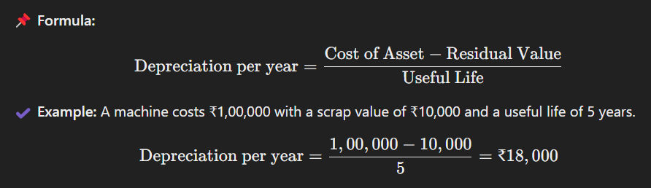

📌 **Characteristics:**

* Simple and easy to calculate.
* Suitable for assets that provide uniform benefits (e.g., furniture, buildings).
* Asset value becomes **zero or scrap value** at the end of its useful life.

**3.2 Written Down Value Method (WDV)**

Under this method, **depreciation is charged as a fixed percentage on the book value of the asset** (reducing balance method).

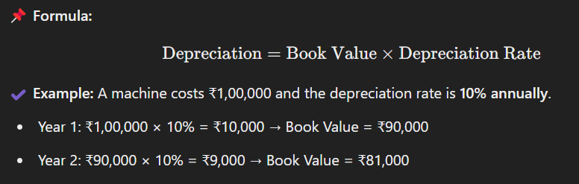

📌 **Characteristics:**

* Higher depreciation in the early years, lower in later years.
* More realistic for assets that lose value faster initially (e.g., vehicles, machinery).
* Never reduces the asset’s value to **zero**.

📌 **Comparison of SLM vs. WDV**

| **Feature** | **Straight Line Method (SLM)** | **Written Down Value Method (WDV)** |
| --- | --- | --- |
| Depreciation per Year | Fixed | Reducing |
| Suitable for | Buildings, furniture | Vehicles, machinery |
| Final Book Value | Reaches zero | Never reaches zero |
| Impact on Profit | Uniform reduction | Higher reduction in early years |

**4. Provisions and Reserves**

**4.1 Provisions**

A **provision** is a liability that a company records to cover an **expected future expense or loss**.

📌 **Examples:**  
✔️ **Provision for Bad Debts** (to cover possible non-payment from customers).  
✔️ **Provision for Depreciation** (amount set aside for asset wear and tear).

**4.2 Reserves**

A **reserve** is a part of profits set aside to strengthen the financial position of the company or for future purposes.

📌 **Examples:**  
✔️ **General Reserve** – Kept for unforeseen expenses.  
✔️ **Dividend Reserve** – Set aside for paying future dividends.

📌 **Difference Between Provisions and Reserves**

| **Feature** | **Provisions** | **Reserves** |
| --- | --- | --- |
| Purpose | To cover a specific expense/loss | To strengthen financial stability |
| Nature | Liability | Retained profit |
| Mandatory? | Yes (as per accounting standards) | No (management decision) |
| Reduces Profit? | Yes | No |
| Shown in | Liabilities (Balance Sheet) | Reserves & Surplus (Balance Sheet) |

**5. Difference Between Capital Reserve and Revenue Reserve**

📌 **Capital Reserve**

* Created from **capital profits** (profits not earned from normal business operations).
* **Not available for dividend distribution**.
* Used for **writing off capital losses** or issuing **bonus shares**.
* **Examples:** Profit on sale of fixed assets, Share Premium.

📌 **Revenue Reserve**

* Created from **normal business profits**.
* Can be used to **distribute dividends**.
* Used for **business expansion or contingencies**.
* **Examples:** General Reserve, Dividend Equalization Reserve.

📌 **Comparison Table**

| **Feature** | **Capital Reserve** | **Revenue Reserve** |
| --- | --- | --- |
| Source | Capital profits | Operating profits |
| Use | Not for dividends, used for capital losses | Can be used for dividends |
| Example | Share premium, profit on sale of assets | General Reserve, Dividend Reserve |
| Shown in Balance Sheet | Under "Reserves & Surplus" | Under "Reserves & Surplus" |

**6. Summary**

📌 **Depreciation** is the reduction in the value of fixed assets over time.  
📌 **Two main methods of depreciation** – **Straight Line Method (SLM)** and **Written Down Value (WDV)**.  
📌 **Depletion** (for natural resources) and **Amortization** (for intangible assets) are similar concepts.  
📌 **Provisions** are made for specific future expenses, whereas **Reserves** strengthen financial stability.  
📌 **Capital Reserves** arise from non-operating profits and cannot be used for dividends, while **Revenue Reserves** come from business profits and can be used for dividends.

**Trial balance and Rectification of Errors**

**• Trial balance: objectives and preparation**

**• Errors: types-errors of omission, commission, principles, and compensating; their effect on**

**Trial Balance**

**• Detection and rectification of errors; preparation of suspense account**

**Trial Balance and Rectification of Errors**

**1. Trial Balance**

**1.1 What is a Trial Balance?**

A **Trial Balance** is a statement that lists the balances of all **ledger accounts** (both debit and credit) to ensure that **total debits equal total credits** in the accounting system. It is prepared at the end of an accounting period to check the accuracy of bookkeeping records.

📌 **Key Features:**  
✔️ Summarizes ledger balances.  
✔️ Used to detect mathematical errors in bookkeeping.  
✔️ Acts as a basis for preparing financial statements (Profit & Loss Account and Balance Sheet).

**1.2 Objectives of Preparing a Trial Balance**

✅ **To check the mathematical accuracy of accounts** – Ensures that total debits match total credits.  
✅ **To facilitate financial statement preparation** – Forms the base for preparing the Profit & Loss Account and Balance Sheet.  
✅ **To detect errors in recording and posting** – Helps in identifying mistakes in accounts.  
✅ **To serve as a summary of ledger accounts** – Provides a consolidated view of all financial transactions.

**1.3 Format of a Trial Balance**

| **Trial Balance as on 31st March 2025** |  
|--------------------------------|------------|------------|  
| **Particulars** | **Debit (₹)** | **Credit (₹)** |  
| Capital | | 5,00,000 |  
| Cash | 50,000 | |  
| Purchases | 2,00,000 | |  
| Sales | | 3,00,000 |  
| Salaries | 30,000 | |  
| Rent | 20,000 | |  
| Furniture | 1,00,000 | |  
| Creditors | | 1,00,000 |  
| **Total** | **4,00,000** | **4,00,000** |

✔ **Total Debit = Total Credit** → Trial Balance is balanced ✅

**2. Errors in Accounting**

Errors in accounting can lead to **imbalance in the Trial Balance** or incorrect financial reporting.

**2.1 Types of Errors**

📌 **(i) Errors of Omission**

* Occurs when a transaction is completely **missed** from the books.
* Example: A sales invoice of ₹10,000 is not recorded in the sales book.
* **Effect on Trial Balance:** No effect if completely omitted; will mismatch if only one side is omitted.

📌 **(ii) Errors of Commission**

* Occurs when an entry is **incorrectly recorded**, such as posting a wrong amount or recording it in the wrong account.
* Example: ₹5,000 received from a debtor is recorded as ₹50,000.
* **Effect on Trial Balance:** Creates an imbalance in trial balance.

📌 **(iii) Errors of Principle**

* Occurs when an item is recorded in the **wrong category**.
* Example: **Machinery purchase recorded as an expense** instead of an asset.
* **Effect on Trial Balance:** No effect but leads to incorrect financial statements.

📌 **(iv) Compensating Errors**

* Errors that **cancel out each other**.
* Example: ₹2,000 **excess debit in Purchases** and ₹2,000 **excess credit in Sales**.
* **Effect on Trial Balance:** No effect, but financial statements are incorrect.

**3. Detection and Rectification of Errors**

**3.1 Detecting Errors in Trial Balance**

✔ Check **ledger postings** to see if the amounts are recorded correctly.  
✔ Verify **debit and credit totals** in the Trial Balance.  
✔ Recalculate **balances of each ledger** to find miscalculations.  
✔ Look for **missing transactions** that may have been omitted.

**3.2 Rectification of Errors**

📌 **(i) Errors Identified Before Preparing Trial Balance**

* Simply correct the incorrect entry in the ledger.
* Example: If **₹5,000 recorded instead of ₹50,000**, correct it by adjusting **₹45,000**.

📌 **(ii) Errors Identified After Preparing Trial Balance**

* If an error **affects only one side**, it is corrected using a **Suspense Account**.
* If an error **affects both debit and credit**, pass a **journal entry** to correct it.

**4. Suspense Account**

When **trial balance does not match**, a **Suspense Account** is used to temporarily record the difference until errors are located and corrected.

**4.1 Example of Suspense Account**

📌 **Case:**  
Total **debit side = ₹4,00,000**, but **credit side = ₹4,10,000**.  
Difference = **₹10,000 (short on debit side)**.

📌 **Solution:**  
Open a **Suspense Account** and debit ₹10,000 to balance the trial balance.

| **Particulars** | **Debit (₹)** | **Credit (₹)** |
| --- | --- | --- |
| **Suspense A/c** | 10,000 | - |

✔ Later, once the mistake is found, the **Suspense Account is closed** by making adjustments.

**5. Summary**

📌 **Trial Balance** ensures that **debit = credit** and helps in financial statement preparation.  
📌 **Types of errors:** **Omission, Commission, Principle, and Compensating Errors**.  
📌 **Errors can be detected by reviewing ledger entries and Trial Balance mismatches**.  
📌 **Errors affecting only one side** are corrected using a **Suspense Account**.  
📌 **Errors affecting both debit and credit** require a **journal entry adjustment**.

**Unit 3: Financial Statements of Sole Proprietorship**

**Financial Statements**

**Preparation of Trading and Profit and Loss account and Balance Sheet of a sole**

**proprietorship with adjustments.**

**Financial Statements of Sole Proprietorship**

**1. Introduction to Financial Statements**

Financial statements are reports that provide insights into the **financial performance and position** of a business. For a **sole proprietorship**, the main financial statements are:

1. **Trading Account** – Calculates **Gross Profit or Gross Loss**.
2. **Profit and Loss Account** – Determines **Net Profit or Net Loss**.
3. **Balance Sheet** – Shows the **financial position** of the business.

**2. Trading Account**

The **Trading Account** calculates the **Gross Profit or Gross Loss** by comparing net sales with the cost of goods sold (COGS).

**Format of Trading Account**

📌 **For the year ending 31st March 2025**

| **Particulars (Dr)** | **₹** | **Particulars (Cr)** | **₹** |
| --- | --- | --- | --- |
| **Opening Stock** | XX | **Sales** | XX |
| **Purchases** | XX | **Less: Sales Return** | (XX) |
| **Add: Direct Expenses** | XX | **Closing Stock** | (XX) |
| **Less: Purchase Return** | (XX) |  |  |
| **Gross Profit c/d** | XX |  |  |
| **Total** | XXXX | **Total** | XXXX |

📌 **Formula for Gross Profit:**

Gross Profit=Net Sales−Cost of Goods Sold\text{Gross Profit} = \text{Net Sales} - \text{Cost of Goods Sold}Gross Profit=Net Sales−Cost of Goods Sold

✔ **If Gross Profit is positive**, it means the business is making a profit from core activities.  
✔ **If Gross Profit is negative**, it indicates losses.

**3. Profit and Loss Account**

The **Profit and Loss Account** calculates the **Net Profit or Net Loss** after considering all indirect expenses and incomes.

**Format of Profit and Loss Account**

📌 **For the year ending 31st March 2025**

| **Particulars (Dr)** | **₹** | **Particulars (Cr)** | **₹** |
| --- | --- | --- | --- |
| **Gross Loss (if any)** | XX | **Gross Profit (from Trading A/c)** | XX |
| **Administrative Expenses** | XX | **Other Income (Commission, Rent Received, etc.)** | XX |
| **Selling & Distribution Expenses** | XX |  |  |
| **Depreciation** | XX |  |  |
| **Net Profit c/d** | XX |  |  |
| **Total** | XXXX | **Total** | XXXX |

📌 **Formula for Net Profit:**

Net Profit=Gross Profit+Other Income−Indirect Expenses\text{Net Profit} = \text{Gross Profit} + \text{Other Income} - \text{Indirect Expenses}Net Profit=Gross Profit+Other Income−Indirect Expenses

✔ **If Net Profit is positive**, the business is making money after covering all expenses.  
✔ **If Net Profit is negative**, it indicates losses.

**4. Balance Sheet**

The **Balance Sheet** represents the **financial position** of the business on a particular date. It consists of:

1. **Assets** (What the business owns)
2. **Liabilities** (What the business owes)
3. **Owner’s Equity** (Capital invested + Profit - Drawings)

**Format of Balance Sheet**

📌 **As on 31st March 2025**

| **Liabilities (Cr)** | **₹** | **Assets (Dr)** | **₹** |
| --- | --- | --- | --- |
| **Capital** | XX | **Fixed Assets (Land, Building, Machinery, etc.)** | XX |
| **Add: Net Profit** | XX | **Current Assets (Cash, Debtors, Stock, etc.)** | XX |
| **Less: Drawings** | (XX) | **Bank Balance** | XX |
| **Long-term Liabilities (Loan, etc.)** | XX | **Prepaid Expenses** | XX |
| **Short-term Liabilities (Creditors, Outstanding Expenses, etc.)** | XX | **Bills Receivable** | XX |
| **Total** | XXXX | **Total** | XXXX |

✔ **Assets = Liabilities + Capital** → This is the fundamental **accounting equation**.

**5. Adjustments in Financial Statements**

Adjustments ensure that **income and expenses** are recorded in the correct period. Common adjustments include:

📌 **(i) Closing Stock**

* Goods remaining unsold at the end of the year.
* Recorded in **Trading Account (credit side)** and **Balance Sheet (asset side)**.

📌 **(ii) Outstanding Expenses**

* Expenses **due but not paid**.
* Added to **Profit & Loss Account (expense side)** and recorded as **liability** in the Balance Sheet.

📌 **(iii) Prepaid Expenses**

* Expenses **paid in advance** for future periods.
* Deducted from **Profit & Loss Account** and shown as **current asset** in Balance Sheet.

📌 **(iv) Accrued Income**

* Income **earned but not received**.
* Added to **Profit & Loss Account (income side)** and shown as **current asset**.

📌 **(v) Depreciation**

* Reduction in asset value due to usage.
* Debited in **Profit & Loss Account** and deducted from asset value in Balance Sheet.

📌 **(vi) Bad Debts**

* Amount that is **irrecoverable from debtors**.
* Debited in **Profit & Loss Account** and deducted from **Sundry Debtors** in Balance Sheet.

📌 **(vii) Interest on Capital**

* Reward given to the proprietor for investing capital.
* Added to **Capital Account** and debited in **Profit & Loss Account**.

📌 **(viii) Drawings**

* Amount withdrawn by the proprietor for personal use.
* Deducted from **Capital Account** in Balance Sheet.

**6. Summary**

📌 **Trading Account** determines **Gross Profit or Gross Loss**.  
📌 **Profit & Loss Account** calculates **Net Profit or Net Loss** after indirect expenses.  
📌 **Balance Sheet** shows the **financial position** of the business.  
📌 **Adjustments like closing stock, depreciation, and outstanding expenses** are essential for accurate reporting.  
📌 **Formula: Assets = Liabilities + Capital** ensures balance in financial statements.

**Unit 4: Financial Statements Analysis**

**• Financial Statement Analysis: Objectives, importance and limitations.**

**• Tools for Financial Statement Analysis: Comparative statements, common size statements,**

**cash flow analysis, ratio analysis.**

**Financial Statement Analysis**

**1. Introduction to Financial Statement Analysis**

**Financial Statement Analysis** involves examining financial statements to understand a business’s performance, profitability, and financial health.

The key financial statements used for analysis are:  
✅ **Trading, Profit & Loss Account** – Shows profit or loss.  
✅ **Balance Sheet** – Shows financial position.  
✅ **Cash Flow Statement** – Analyzes cash inflows and outflows.

**2. Objectives of Financial Statement Analysis**

🔹 **Assess Financial Performance** – Helps in evaluating a company’s profitability.  
🔹 **Evaluate Liquidity & Solvency** – Determines whether a business can meet its short-term and long-term obligations.  
🔹 **Measure Operational Efficiency** – Helps in analyzing how well the business utilizes resources.  
🔹 **Facilitate Decision-Making** – Assists investors, management, and other stakeholders in making financial decisions.  
🔹 **Compare with Competitors** – Helps in benchmarking against industry peers.

**3. Importance of Financial Statement Analysis**

📌 **For Investors:** Helps in investment decisions by assessing profitability and growth potential.  
📌 **For Management:** Guides in financial planning, budgeting, and strategy formulation.  
📌 **For Creditors & Lenders:** Assists in determining the creditworthiness of a business.  
📌 **For Government & Regulators:** Ensures transparency and compliance with financial laws.

**4. Limitations of Financial Statement Analysis**

⚠ **Historical Data:** Financial statements reflect past performance and may not predict future trends.  
⚠ **Non-Financial Factors Ignored:** It does not consider factors like employee morale, brand value, or market reputation.  
⚠ **Accounting Policies Vary:** Different companies may use different accounting methods, making comparison difficult.  
⚠ **Manipulation Possibility:** Companies may alter financial statements to appear more profitable (window dressing).  
⚠ **Inflation Impact:** Statements may not reflect the true value of assets and liabilities due to inflation.

**5. Tools for Financial Statement Analysis**

**5.1 Comparative Financial Statements**

🔹 **Definition:** Shows financial data of multiple years side-by-side to identify trends and changes.  
🔹 **Example:** Comparing **revenue, expenses, and profits** over **two or more years**.

| **Particulars** | **2023 (₹)** | **2024 (₹)** | **Change (₹)** | **% Change** |
| --- | --- | --- | --- | --- |
| Sales Revenue | 5,00,000 | 6,00,000 | +1,00,000 | +20% |
| Net Profit | 1,20,000 | 1,50,000 | +30,000 | +25% |

📌 **Usage:** Helps in tracking business growth, cost control, and efficiency improvement.

**5.2 Common Size Statements**

🔹 **Definition:** Expresses all items as a **percentage of total assets (Balance Sheet)** or **total revenue (P&L Account)** for comparison.  
🔹 **Example:**

📌 **Common Size Income Statement**

| **Particulars** | **₹ Amount** | **% of Sales** |
| --- | --- | --- |
| Sales Revenue | 5,00,000 | 100% |
| Cost of Goods Sold | 3,00,000 | 60% |
| Gross Profit | 2,00,000 | 40% |
| Operating Expenses | 50,000 | 10% |
| Net Profit | 1,50,000 | 30% |

📌 **Usage:** Helps in comparing financials of different companies irrespective of size.

**5.3 Cash Flow Analysis**

🔹 **Definition:** Examines the movement of cash **inflows and outflows** during a period.  
🔹 **Cash Flow Activities:**  
✅ **Operating Activities:** Cash generated from business operations (e.g., sales, expenses).  
✅ **Investing Activities:** Cash spent or earned from investments (e.g., buying/selling assets).  
✅ **Financing Activities:** Cash raised through loans or owner investments.

📌 **Example:**

| **Particulars** | **₹ Amount** |
| --- | --- |
| **Cash Flow from Operating Activities** | +2,00,000 |
| **Cash Flow from Investing Activities** | -50,000 |
| **Cash Flow from Financing Activities** | +1,00,000 |
| **Net Cash Flow** | **+2,50,000** |

📌 **Usage:** Helps in understanding whether a company is generating enough cash to sustain itself.

**5.4 Ratio Analysis**

🔹 **Definition:** Uses financial ratios to evaluate performance, efficiency, and financial health.

📌 **Types of Ratios:**

1️⃣ **Liquidity Ratios** – Measures ability to meet short-term obligations.  
✔ **Current Ratio** = **Current Assets / Current Liabilities**  
✔ **Quick Ratio** = **(Current Assets - Inventory) / Current Liabilities**

2️⃣ **Profitability Ratios** – Measures earnings capability.  
✔ **Gross Profit Margin** = **(Gross Profit / Sales) × 100**  
✔ **Net Profit Margin** = **(Net Profit / Sales) × 100**  
✔ **Return on Investment (ROI)** = **(Net Profit / Capital Employed) × 100**

3️⃣ **Solvency Ratios** – Measures long-term financial stability.  
✔ **Debt-to-Equity Ratio** = **Total Debt / Shareholder’s Equity**

4️⃣ **Efficiency Ratios** – Measures asset utilization efficiency.  
✔ **Inventory Turnover Ratio** = **Cost of Goods Sold / Average Inventory**

📌 **Example:** If a business has **Sales of ₹10,00,000** and a **Net Profit of ₹2,00,000**, then:

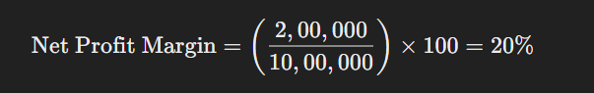

📌 **Usage:** Helps in measuring profitability, liquidity, and financial health of a company.

**6. Summary**

📌 **Financial Statement Analysis** helps assess business performance, liquidity, and solvency.  
📌 **Comparative Statements** highlight year-over-year changes.  
📌 **Common Size Statements** compare financials across companies.  
📌 **Cash Flow Analysis** checks liquidity and cash movements.  
📌 **Ratio Analysis** provides key insights into profitability, efficiency, and financial stability.

**Unit 5: Understanding Cost**

**• Meaning of Cost, Objective of Costing, Methods of Costing, Technique of Costing,**

**Classification of Cost, Elements of Cost, Statement of Cost Sheet, Solved Problems**

**• Material Costing. Methods of Valuation of Material issue. Concept and material control and**

**its techniques.**

**Understanding Cost**

**1. Meaning of Cost**

**Cost** refers to the total expenses incurred in producing goods or services. It includes raw materials, labor, and overhead costs.

📌 **Example:** If a company spends ₹500 on raw materials, ₹300 on wages, and ₹200 on factory expenses, the total cost is ₹1,000.

**2. Objectives of Costing**

🔹 **Determine Cost of Production** – Helps in finding the actual cost of manufacturing a product.  
🔹 **Control Costs** – Helps businesses reduce unnecessary expenses.  
🔹 **Fix Selling Price** – Ensures that products are priced profitably.  
🔹 **Measure Efficiency** – Evaluates how resources are used.  
🔹 **Assist in Decision Making** – Helps in make-or-buy decisions and pricing strategies.

**3. Methods of Costing**

Different industries use different costing methods based on their production processes.

| **Method** | **Industry Example** |
| --- | --- |
| **Job Costing** | Customized products (e.g., Furniture, Shipbuilding) |
| **Batch Costing** | Manufacturing in batches (e.g., Pharmaceuticals, Clothing) |
| **Process Costing** | Continuous production (e.g., Oil refining, Chemicals) |
| **Contract Costing** | Large projects (e.g., Construction, Civil Engineering) |
| **Operating Costing** | Service industries (e.g., Transport, Hotels) |

**4. Techniques of Costing**

🔹 **Marginal Costing** – Analyzing only variable costs while ignoring fixed costs in decision-making.  
🔹 **Standard Costing** – Comparing actual costs with predetermined costs to find variances.  
🔹 **Budgetary Control** – Preparing budgets to control expenses.  
🔹 **Absorption Costing** – Includes all costs (fixed + variable) in product pricing.  
🔹 **Activity-Based Costing (ABC)** – Allocates costs based on activities that generate expenses.

**5. Classification of Cost**

Costs can be classified into different categories for better cost control.

**A. Based on Behavior**

✔ **Fixed Cost** – Does not change with production (e.g., Rent, Salaries).  
✔ **Variable Cost** – Changes with production (e.g., Raw Materials, Wages).  
✔ **Semi-Variable Cost** – Partially fixed, partially variable (e.g., Electricity Bill).

**B. Based on Function**

✔ **Production Cost** – Costs related to manufacturing.  
✔ **Administrative Cost** – Office expenses.  
✔ **Selling & Distribution Cost** – Advertising and delivery expenses.

**C. Based on Traceability**

✔ **Direct Cost** – Can be directly assigned to a product (e.g., Raw Material).  
✔ **Indirect Cost** – Cannot be directly assigned (e.g., Factory Rent, Office Supplies).

**6. Elements of Cost**

A cost sheet consists of three main cost elements:

🔹 **Material Cost** – Cost of raw materials used in production.  
🔹 **Labour Cost** – Wages paid to workers involved in production.  
🔹 **Overhead Cost** – Indirect expenses like rent, electricity, and machinery maintenance.

📌 **Example:**

| **Cost Element** | **Amount (₹)** |
| --- | --- |
| **Direct Material** | 20,000 |
| **Direct Labour** | 10,000 |
| **Factory Overheads** | 5,000 |
| **Total Production Cost** | **35,000** |

**7. Statement of Cost Sheet**

A **cost sheet** is a detailed statement showing the total cost incurred to produce goods.

| **Particulars** | **Amount (₹)** |
| --- | --- |
| **Direct Material** | 50,000 |
| **Direct Labour** | 30,000 |
| **Direct Expenses** | 10,000 |
| **Prime Cost (A)** | **90,000** |
| **Factory Overheads** | 20,000 |
| **Factory Cost (B)** | **1,10,000** |
| **Administrative Overheads** | 10,000 |
| **Total Cost (C)** | **1,20,000** |
| **Profit** | 30,000 |
| **Selling Price** | **1,50,000** |

**8. Material Costing**

Material costing is the process of determining the cost of raw materials used in production.

**Methods of Valuation of Material Issue**

🔹 **FIFO (First-In-First-Out)** – Oldest stock is used first.  
🔹 **LIFO (Last-In-First-Out)** – Newest stock is used first.  
🔹 **Weighted Average Cost** – Average cost of all materials is used.  
🔹 **Specific Identification** – Used when materials are specifically identifiable (e.g., diamonds).

📌 **Example (FIFO Method):**

| **Date** | **Purchase (Units @ ₹)** | **Issue (Units)** | **Remaining Stock** |
| --- | --- | --- | --- |
| 01 Jan | 100 @ ₹5 | - | 100 @ ₹5 |
| 05 Jan | 50 @ ₹6 | - | 100 @ ₹5 + 50 @ ₹6 |
| 10 Jan | - | 120 | 30 @ ₹6 |

**9. Concept of Material Control & Its Techniques**

Material control ensures the right materials are available at the right time to prevent wastage.

📌 **Techniques for Material Control:**  
✔ **Economic Order Quantity (EOQ):** The optimal order size that minimizes cost.  
✔ **ABC Analysis:** Categorizing materials as **A (high value), B (medium value), C (low value)**.  
✔ **Just-In-Time (JIT):** Purchasing materials only when needed to reduce storage costs.  
✔ **Perpetual Inventory System:** Continuous tracking of inventory.

**10. Solved Problem – Cost Sheet Example**

📌 **Question:** Prepare a cost sheet based on the following information:  
🔹 Direct Material – ₹40,000  
🔹 Direct Labour – ₹20,000  
🔹 Factory Overheads – ₹10,000  
🔹 Administrative Overheads – ₹5,000  
🔹 Selling & Distribution Overheads – ₹7,000  
🔹 Profit – 20% of total cost

📌 **Solution:**

| **Particulars** | **Amount (₹)** |
| --- | --- |
| **Direct Material** | 40,000 |
| **Direct Labour** | 20,000 |
| **Prime Cost (A)** | **60,000** |
| **Factory Overheads** | 10,000 |
| **Factory Cost (B)** | **70,000** |
| **Administrative Overheads** | 5,000 |
| **Total Cost (C)** | **75,000** |
| **Selling & Distribution Overheads** | 7,000 |
| **Cost of Sales (D)** | **82,000** |
| **Profit (20% of Cost)** | **16,400** |
| **Selling Price** | **98,400** |

📌 **Answer:** The final selling price is ₹98,400.

**11. Summary**

✔ **Costing helps in determining production costs and fixing selling prices.**  
✔ **Methods like Job Costing, Process Costing, and Batch Costing are used in different industries.**  
✔ **Elements of Cost include Material, Labour, and Overheads.**  
✔ **Material valuation methods like FIFO, LIFO, and Weighted Average help in inventory management.**  
✔ **Cost Sheets help track total production costs and profit margins.**

**Unit 6: Marginal Costing and Break Even Analysis**

**Concept of Marginal Costing, Characteristics of Marginal Costing, Difference between**

**Absorption Costing and Marginal Costing, Marginal Cost, Contribution , Cost Volume**

**Profit (CVP) Analysis, Break Even Chart, Break Even Point , Profit Volume ratio, Margin**

**of Safety, Solved Problems**

**Marginal Costing and Break-Even Analysis**

**1. Concept of Marginal Costing**

**Marginal costing** is a technique where only variable costs are considered for decision-making, and fixed costs are treated as period costs. This helps in **cost-volume-profit (CVP) analysis** and determining the **break-even point (BEP).**



**2. Characteristics of Marginal Costing**

✔ **Fixed and Variable Costs are Separated:** Only variable costs are considered for decision-making.  
✔ **Fixed Costs are Treated as Period Costs:** Fixed costs are not included in product cost.  
✔ **Inventory is Valued at Variable Cost:** Fixed costs are not added to inventory valuation.  
✔ **Profit is Determined Using Contribution:** Profit depends on contribution margin rather than gross profit.  
✔ **Decision Making is Simplified:** Helps in pricing, profit planning, and cost control.

**3. Difference Between Marginal Costing and Absorption Costing**

| **Basis** | **Marginal Costing** | **Absorption Costing** |
| --- | --- | --- |
| **Treatment of Fixed Cost** | Treated as period cost | Included in product cost |
| **Inventory Valuation** | Valued at variable cost only | Valued at total cost (fixed + variable) |
| **Profit Calculation** | Based on contribution | Based on gross profit |
| **Decision Making** | Useful for short-term decisions | Suitable for long-term pricing and profitability |
| **Break-even Analysis** | Easier as fixed costs are separate | Complex due to fixed cost inclusion |

**4. Marginal Cost and Contribution**

🔹 **Marginal Cost**: Additional cost incurred for producing one extra unit.  
🔹 **Contribution**: The amount available to cover fixed costs and generate profit.

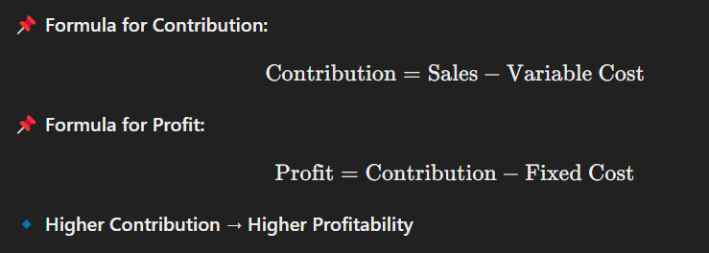

**5. Cost-Volume-Profit (CVP) Analysis**

**CVP Analysis** examines the relationship between **sales volume, costs, and profits** to help businesses make decisions about pricing, production levels, and profit targets.

📌 **Key Components of CVP Analysis:**  
✔ **Break-even point (BEP)** – No profit, no loss situation.  
✔ **Profit-Volume Ratio (P/V Ratio)** – Measures profitability per ₹1 of sales.  
✔ **Margin of Safety (MOS)** – The cushion above the break-even sales level.

**6. Break-Even Point (BEP)**

**BEP** is the sales volume where **total revenue = total cost** (no profit, no loss).

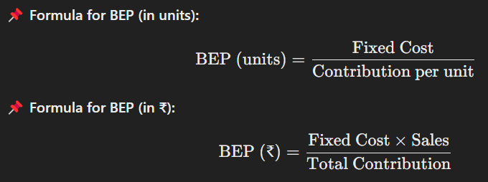

**7. Profit-Volume (P/V) Ratio**

The **P/V ratio** measures how efficiently a business converts sales into profits.

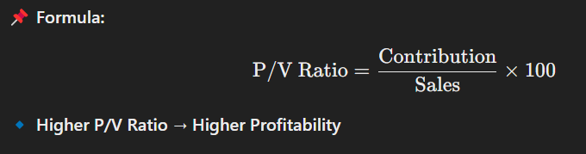

**8. Margin of Safety (MOS)**

The **margin of safety** is the difference between actual sales and break-even sales. It shows the extent to which sales can drop before a company incurs losses.

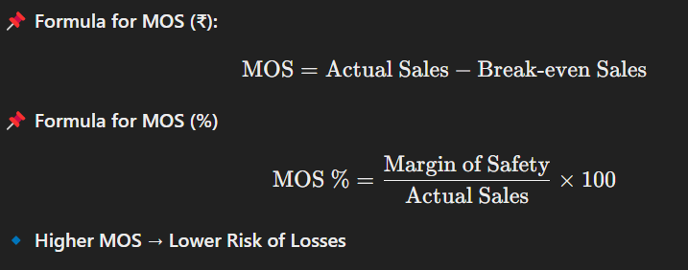

**9. Break-Even Chart**

A **Break-Even Chart** is a graphical representation of costs, revenue, and profit at different sales levels.

📌 **Key Points in a Break-Even Chart:**  
✔ **Total Cost Line** – Sum of fixed and variable costs.  
✔ **Revenue Line** – Sales revenue at different levels.  
✔ **Break-Even Point (BEP)** – The intersection of total cost and revenue lines.  
✔ **Profit Area** – Above BEP (Revenue > Costs).  
✔ **Loss Area** – Below BEP (Revenue < Costs).

**10. Solved Problems**

**Problem 1: Find BEP in units**

🔹 Given:

* Fixed Costs = ₹50,000
* Selling Price per unit = ₹20
* Variable Cost per unit = ₹10

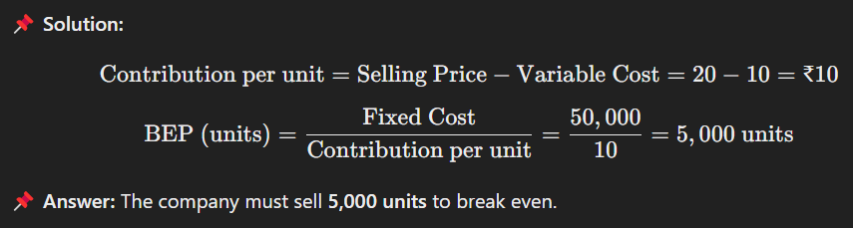

**Problem 2: Find MOS (%)**

🔹 Given:

* Actual Sales = ₹2,00,000
* Break-even Sales = ₹1,50,000

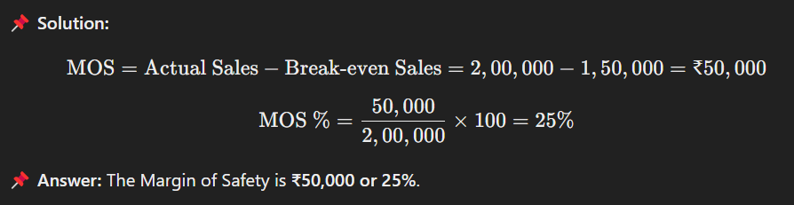

**Problem 3: Find Profit using Contribution Approach**

🔹 Given:

* Sales = ₹3,00,000
* Variable Cost = ₹1,50,000
* Fixed Cost = ₹75,000

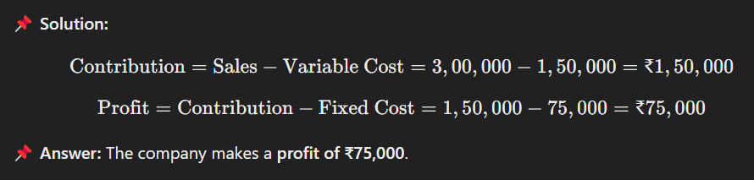

**11. Summary**

✔ **Marginal Costing helps in short-term decision-making.**  
✔ **Fixed costs are treated as period costs, while only variable costs are considered for product costing.**  
✔ **Break-even analysis determines the sales level where the business covers all costs.**  
✔ **Key ratios like P/V Ratio and MOS help measure profitability and risk.**  
✔ **CVP Analysis is useful for profit planning and cost control.**

**Unit 7: Utility and Consumer Behaviour**

**Utility and different approaches to utility--cardinal andordinal approach--relationship**

**between total and marginal utility--law of diminishingmarginal utility and its explanations--**

**Indifference curve--definition, features and differentshapes –marginalrate of substitution--**

**Budget line and its slope, shift and rotation—Consumerequilibrium--conditions and**

**economic interpretation--Income consumption curve and priceconsumption curve**

**Utility and Consumer Behaviour**

**1. Utility and Different Approaches to Utility**

**Utility** refers to the **satisfaction or pleasure** a consumer derives from consuming goods or services. It is subjective and varies from person to person.

**Types of Utility**

🔹 **Total Utility (TU):** The total satisfaction obtained from consuming a given quantity of goods.  
🔹 **Marginal Utility (MU):** The additional utility gained from consuming one more unit of a good.

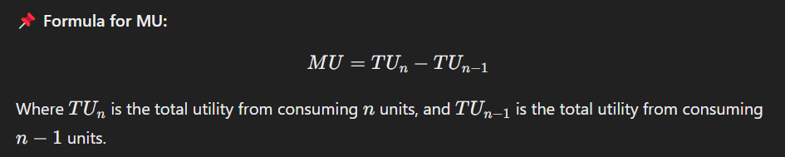

**2. Cardinal and Ordinal Approaches to Utility**

**A. Cardinal Approach (Marshallian Approach)**

This approach assumes that **utility can be measured in numerical values (utils).** It is based on the **Law of Diminishing Marginal Utility (DMU).**

📌 **Key Assumptions:**  
✔ Consumers are rational and aim to maximize utility.  
✔ Utility is **measurable in utils** (hypothetical units of satisfaction).  
✔ MU of money remains **constant**.  
✔ Goods are homogeneous.

**B. Ordinal Approach (Indifference Curve Analysis - Hicks & Allen)**

This approach states that utility **cannot be measured numerically but can be ranked** in order of preference.

📌 **Key Features:**  
✔ Consumers can **rank** their preferences but cannot assign numerical values to satisfaction.  
✔ Based on **Indifference Curve Analysis** and the **Marginal Rate of Substitution (MRS).**  
✔ Uses a **Budget Line** to determine consumer equilibrium.

**3. Relationship Between Total Utility (TU) and Marginal Utility (MU)**

| **Units Consumed** | **Total Utility (TU)** | **Marginal Utility (MU)** |
| --- | --- | --- |
| 1 | 10 | 10 |
| 2 | 18 | 8 |
| 3 | 24 | 6 |
| 4 | 28 | 4 |
| 5 | 30 | 2 |
| 6 | 30 (max) | 0 |
| 7 | 28 | -2 (disutility) |

🔹 **MU is positive** when TU increases.  
🔹 **MU is zero** when TU reaches its maximum (saturation point).  
🔹 **MU becomes negative** when TU starts decreasing (disutility).

**4. Law of Diminishing Marginal Utility (DMU)**

The **Law of DMU** states that **as more units of a good are consumed, the additional (marginal) utility derived from each successive unit decreases.**

📌 **Example:**  
Eating the first slice of pizza gives the most satisfaction. The second slice provides less utility, and by the fifth or sixth slice, utility may turn negative (disutility).

📌 **Graphical Representation:**

* TU curve **increases at a decreasing rate** and then flattens out.
* MU curve **declines and eventually turns negative.**

**Assumptions of DMU:**

✔ Consumer is **rational** and aims to maximize satisfaction.  
✔ Utility is **cardinally measurable**.  
✔ Consumption occurs **continuously**.  
✔ Quality and preferences **remain constant**.

**5. Indifference Curve Analysis**

**Indifference Curve (IC):**

An **indifference curve** represents a combination of two goods that give the consumer **equal satisfaction**.

📌 **Features of Indifference Curves:**  
✔ **Downward sloping:** More of one good requires less of another to maintain the same utility.  
✔ **Convex to the origin:** Due to the **Law of Diminishing Marginal Rate of Substitution (MRS).**  
✔ **Higher IC represents higher satisfaction.**  
✔ **Indifference curves never intersect.**

**Marginal Rate of Substitution (MRS):**

**MRS** is the rate at which a consumer is willing to exchange one good for another while maintaining the same level of satisfaction.



**6. Budget Line and Consumer Equilibrium**

**A. Budget Line**

A **budget line** represents all possible combinations of two goods that a consumer can purchase given their **income and prices**.

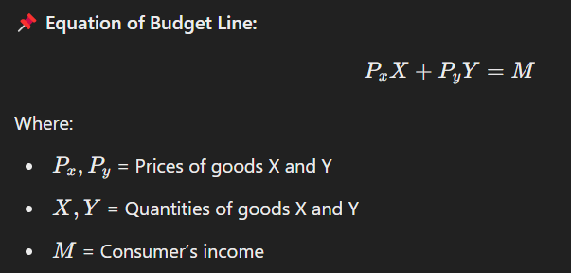

📌 **Budget Line Shifts & Rotations:**  
✔ **Income Increase → Parallel shift outward** (more purchasing power).  
✔ **Income Decrease → Parallel shift inward** (less purchasing power).  
✔ **Change in Price of One Good → Rotation of the budget line.**

**B. Consumer Equilibrium**

A consumer is in **equilibrium** when they maximize their satisfaction **subject to their budget constraint**.

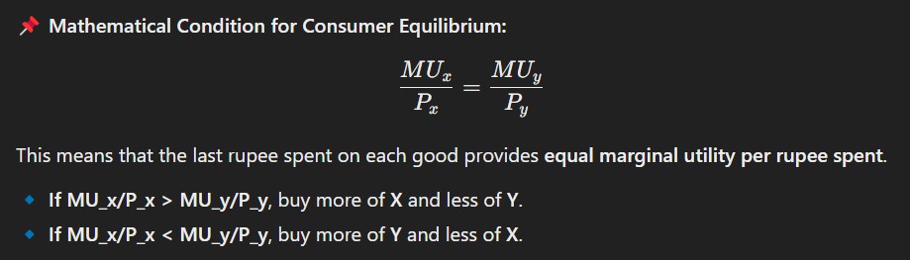

**7. Income and Price Consumption Curves**

**A. Income Consumption Curve (ICC):**

Shows how a consumer’s **demand changes with income**, keeping prices constant.

* **Normal goods:** Demand increases as income increases.
* **Inferior goods:** Demand decreases as income increases.

**B. Price Consumption Curve (PCC):**

Shows how a consumer’s **demand changes when the price of one good changes**, keeping income constant.

* **Downward PCC:** Normal good
* **Backward bending PCC:** Giffen good (price increase leads to more demand due to strong income effect).

**8. Summary**

✔ **Cardinal Approach** assumes utility is measurable, while **Ordinal Approach** uses **Indifference Curve Analysis**.  
✔ **Law of Diminishing Marginal Utility** explains why marginal utility declines as consumption increases.  
✔ **Indifference Curves** represent equal satisfaction levels; **MRS declines** along an IC.  
✔ **Budget Line shows spending constraints**, and **Consumer Equilibrium occurs when MU per rupee spent is equal** across goods.  
✔ **Income Consumption Curve** shows demand changes with income, and **Price Consumption Curve** shows demand changes with price.

**Unit 8: Theory of Demand**

**Demand and its determinants--Law of demand and its exceptions; Demand function and**

**reasons for the negative slope of the demand curve--change in demandversus change in**

**quantity demanded; Law of supply and the determinants of supply; priceelasticity of demand**

**and its measurement--relationship between slope and elasticity of thedemand curve--income**

**elasticity of demand and the nature of the goods ( Superior, normal,neutral and inferior)--**

**Cross price elasticity of demand and the relationship between different goods; Concept of**

**equilibrium through the interaction of demand and the supply curve**

**Theory of Demand**

**1. Demand and Its Determinants**

**Definition of Demand**

Demand refers to the quantity of a good or service that consumers are **willing and able to purchase** at different prices during a given period.

**Determinants of Demand**

The factors affecting demand are:  
✔ **Price of the Good (P):** Inverse relationship with demand (Law of Demand).  
✔ **Income of Consumers (Y):** Normal goods → demand increases with income, Inferior goods → demand decreases with income.  
✔ **Prices of Related Goods:**

* **Substitutes (tea & coffee):** If the price of tea rises, demand for coffee increases.
* **Complements (car & petrol):** If petrol prices rise, demand for cars may fall.  
  ✔ **Consumer Preferences (T):** Changes due to trends, advertisements, etc.  
  ✔ **Future Price Expectations (E):** If consumers expect prices to rise, they buy more now.  
  ✔ **Population & Demographics (D):** Higher population → higher demand.  
  ✔ **Government Policies (G):** Taxes, subsidies, and regulations can influence demand.

**2. Law of Demand & Its Exceptions**

**Law of Demand**

📌 **Statement:** "Other things remaining constant (ceteris paribus), as the price of a good increases, its demand decreases and vice versa."

📌 **Graphical Representation:**  
The demand curve slopes **downward from left to right** due to the inverse relationship between price and quantity demanded.

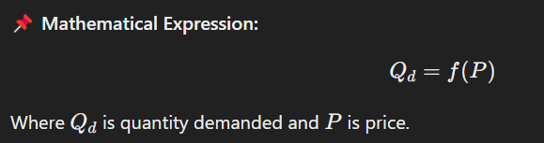

📌 **Reasons for the Negative Slope:**  
✔ **Substitution Effect:** When a good’s price increases, consumers switch to substitutes.  
✔ **Income Effect:** Higher prices reduce consumers’ purchasing power, lowering demand.  
✔ **Diminishing Marginal Utility:** Additional units provide less satisfaction, so consumers buy less.

**Exceptions to the Law of Demand**

🚫 **Giffen Goods:** Inferior goods where a price rise leads to more demand (e.g., staple foods like rice in very poor regions).  
🚫 **Veblen Goods (Prestige Goods):** Higher prices increase demand due to status symbol appeal (e.g., luxury cars).  
🚫 **Future Price Expectations:** If consumers expect prices to rise further, they buy more even at high prices.  
🚫 **Essential Goods:** Medicines or necessities may have inelastic demand, regardless of price.

**3. Demand Function**

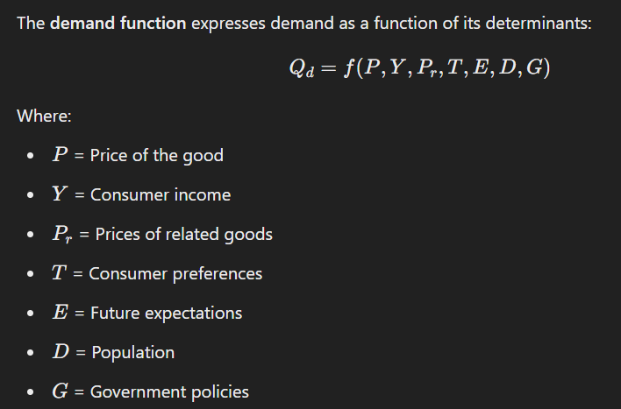

**4. Change in Demand vs. Change in Quantity Demanded**

**Change in Quantity Demanded**

🔹 **Movement along the Demand Curve** due to a change in price.  
🔹 **No shift** in the demand curve.

📌 **Example:** A fall in the price of oranges from ₹100 to ₹80 increases demand from 10kg to 15kg.

**Change in Demand**

🔹 **Shift of the Demand Curve** due to non-price factors (income, preferences, etc.).  
🔹 **Rightward shift (increase in demand):** Higher income, positive consumer trends.  
🔹 **Leftward shift (decrease in demand):** Higher taxes, negative trends.

📌 **Example:** A rise in consumer income may shift the demand curve for cars **rightward**.

**5. Law of Supply & Its Determinants**

**Law of Supply**

📌 **Statement:** "Other things being constant, as the price of a good increases, the quantity supplied also increases and vice versa."

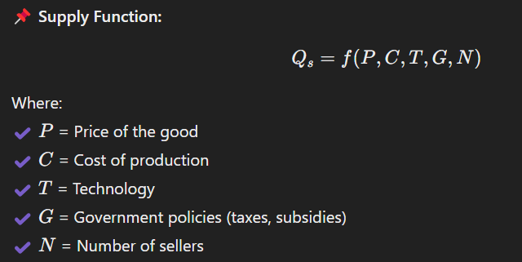

📌 **Graphical Representation:**  
The supply curve slopes **upward from left to right**, showing a direct relationship between price and quantity supplied.

**6. Price Elasticity of Demand (PED)**

**Definition:**

PED measures how much quantity demanded **changes in response to a price change.**

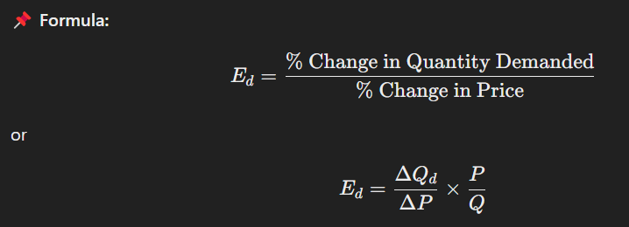

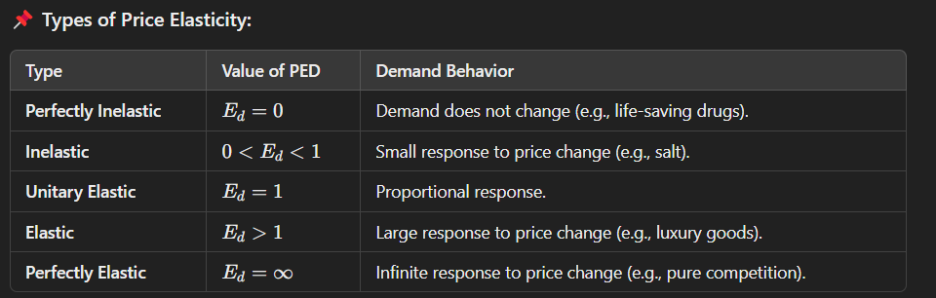

📌 **Relationship Between Slope & Elasticity:**  
✔ A flatter demand curve → More elastic demand.  
✔ A steeper demand curve → More inelastic demand.

**7. Other Types of Elasticities**

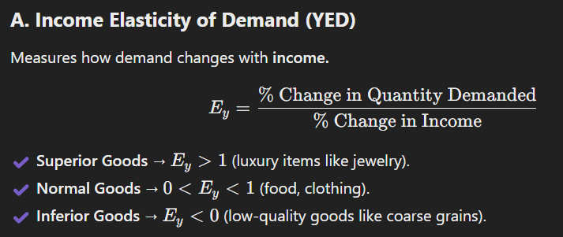

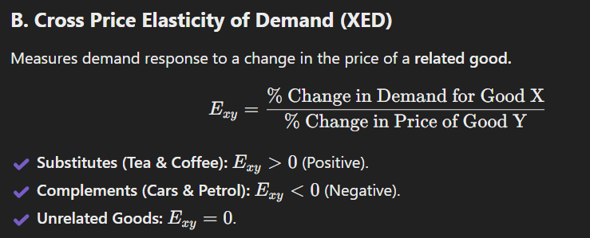

**8. Market Equilibrium Through Demand & Supply Interaction**

📌 **Equilibrium Price & Quantity:**  
Occurs where **Demand = Supply**.

📌 **Effects of Changes in Demand & Supply:**  
✔ **Increase in Demand → Higher equilibrium price & quantity.**  
✔ **Increase in Supply → Lower equilibrium price & higher quantity.**  
✔ **Simultaneous increase in both → Quantity rises, price change depends on magnitude.**



**Conclusion**

✔ **Law of Demand:** Inverse relation between price & quantity demanded.  
✔ **Price Elasticity of Demand:** Measures sensitivity to price changes.  
✔ **Market Equilibrium:** Achieved when demand equals supply.

**Unit 9: Theory of production**

**Production function and the factors of production; short run and long run; relationship**

**among total product, average product and marginal product of the variable factor; Stages of**

**production; Law of variable proportion--Returns to scale andreturns to the factor; Isoquant,**

**Isocost and producer’s equilibrium; Expansion path**

**Theory of Production**

**1. Production Function & Factors of Production**

**Definition of Production**

Production refers to the process of **transforming inputs (resources) into outputs (goods and services)**.

**Production Function**

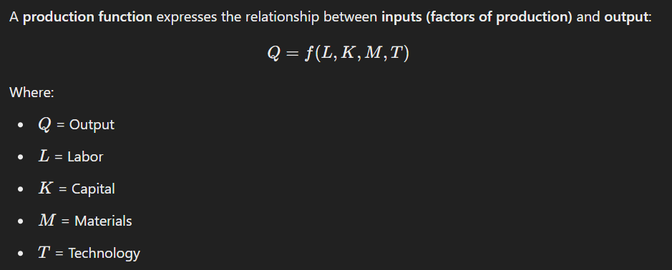

**Factors of Production**

1. **Land** – Natural resources.
2. **Labor** – Human effort.
3. **Capital** – Machines, tools, infrastructure.
4. **Entrepreneurship** – Management & innovation.

**2. Short Run vs. Long Run Production**

**Short Run Production**

🔹 **At least one input is fixed** (e.g., capital is fixed, labor is variable).  
🔹 Firms can increase output only by **adding more of the variable factor**.

**Long Run Production**

🔹 **All inputs are variable** (firms can adjust capital & labor).  
🔹 Firms can **change scale of production** (expand or reduce).

**3. Relationship Among Total, Average, and Marginal Product**

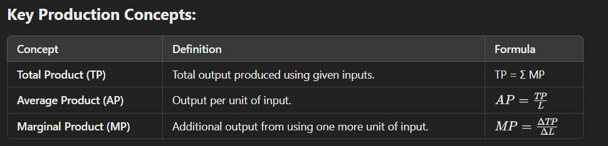

📌 **Graphical Relationship:**  
✔ **MP initially rises**, reaches a peak, and then falls.  
✔ **AP follows MP**, but peaks later.  
✔ **TP increases at a decreasing rate after MP starts falling.**

📌 **Key Rule:**  
When **MP > AP**, AP rises.  
When **MP < AP**, AP falls.

**4. Stages of Production**

**Stage I: Increasing Returns to the Variable Factor**  
✔ TP increases at an increasing rate.  
✔ MP is rising.  
✔ AP is also rising.

**Stage II: Diminishing Returns to the Variable Factor**  
✔ TP increases at a decreasing rate.  
✔ MP is falling but still positive.  
✔ AP starts declining.

**Stage III: Negative Returns to the Variable Factor**  
✔ TP starts declining.  
✔ MP becomes negative.  
✔ AP continues to fall.

**Conclusion:** Firms operate in **Stage II** where MP is positive but diminishing.

**5. Law of Variable Proportions**

📌 **Statement:** "As more units of a variable input are added to a fixed input, **output initially increases at an increasing rate, then at a decreasing rate, and finally declines**."

📌 **Assumptions:**  
✔ One factor is **fixed** (e.g., land), others are variable.  
✔ Technology remains **constant**.  
✔ **Short run** phenomenon.

📌 **Causes of Each Stage:**  
✔ **Stage I:** Better utilization of fixed resources.  
✔ **Stage II:** Optimal combination of inputs.  
✔ **Stage III:** Overcrowding, inefficiency.

📌 **Practical Example:**  
Adding more workers in a factory improves productivity **only up to a point**; beyond that, overcrowding reduces efficiency.

**6. Returns to Scale vs. Returns to a Factor**

**Returns to Scale (Long Run)**

📌 **Definition:** How output changes when **all inputs** are changed **proportionally**.

| **Type** | **Explanation** |
| --- | --- |
| **Increasing Returns to Scale (IRS)** | Output increases **more than** proportionally to inputs. |
| **Constant Returns to Scale (CRS)** | Output increases **proportionally** to inputs. |
| **Decreasing Returns to Scale (DRS)** | Output increases **less than** proportionally to inputs. |

📌 **Example:**  
✔ **Doubling all inputs →** Output **more than doubles** (IRS).  
✔ **Doubling all inputs →** Output **exactly doubles** (CRS).  
✔ **Doubling all inputs →** Output **less than doubles** (DRS).

**Returns to a Factor (Short Run)**

📌 **Definition:** Output change when **one input changes**, keeping others constant.  
✔ Related to **Law of Variable Proportions**.

**7. Isoquant, Isocost, and Producer’s Equilibrium**

**Isoquant (Equal Output Curve)**

📌 **Definition:** A curve showing different combinations of inputs (labor & capital) **yielding the same output**.  
✔ Similar to an **indifference curve**, but for producers.  
✔ **Higher isoquants → Higher production levels.**

**Isocost Line (Equal Cost Line)**

📌 **Definition:** Represents all possible combinations of inputs **at a given cost**.  
✔ **Slope:** Ratio of input prices (Labor/Capital).  
✔ **Shifts if** budget changes.

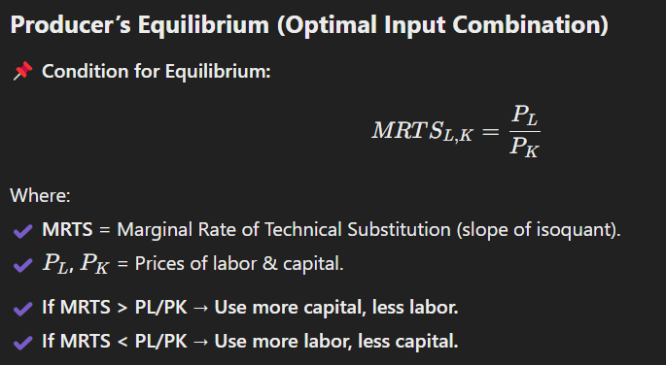

**8. Expansion Path**

📌 **Definition:**  
A curve showing the **least-cost combination of inputs** as a firm expands production.

✔ **Upward sloping** – More inputs lead to higher output.  
✔ **Indicates efficient input usage** as costs change.

**Conclusion**

✔ **Short Run:** **Law of Variable Proportions** governs production.  
✔ **Long Run:** **Returns to Scale** determine efficiency.  
✔ **Optimal Production:** Achieved at **producer’s equilibrium**.  
✔ **Isoquants & Isocosts:** Help firms **minimize cost** and **maximize output**.

**Unit 10: Theory of cost**

**Cost function; Total fixed cost (TFC), Total Variable Cost (TVC), Total cost(TC), Average**

**fixed Cost (AFC), Average Variable Cost (AVC), Average Cost (AC), Marginal Cost**

**(MC);Shapes and relationships; Relationship between AC and MC ;Reason for the “U”**

**shapeof short run average cost curve ; Long run Average cost Curve (LAC) and its**

**relationship withShort Run Average Cost Curves(SACs); Envelope curve**

**Theory of Cost**

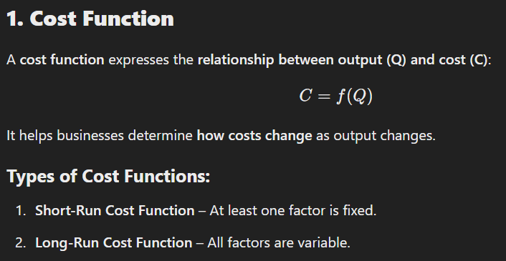

**2. Types of Costs in the Short Run**

**Total Costs:**

| **Type** | **Definition** | **Formula** |
| --- | --- | --- |
| **Total Fixed Cost (TFC)** | Cost that does not change with output. | Fixed Expenses |
| **Total Variable Cost (TVC)** | Cost that changes with output. | TVC = Σ Variable Costs |
| **Total Cost (TC)** | Sum of TFC and TVC. | TC = TFC + TVC |

📌 **Graphical Representation:**  
✔ **TFC is a horizontal line** (constant cost).  
✔ **TVC increases with output.**  
✔ **TC starts from TFC and rises as TVC increases.**

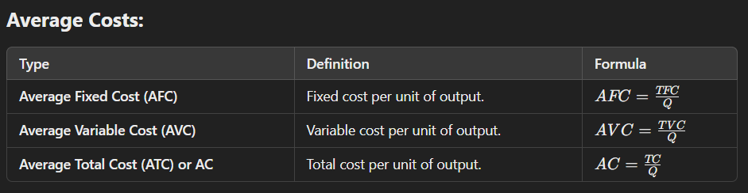

📌 **Graphical Representation:**  
✔ **AFC declines as output increases** (spreading effect).  
✔ **AVC and AC are U-shaped** (due to the Law of Variable Proportions).

**Marginal Cost (MC):**

📌 **Definition:**  
The **additional cost** incurred to produce **one more unit** of output.

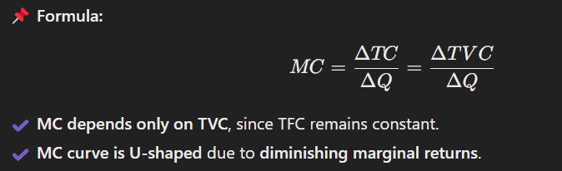

**3. Relationship Between AC and MC**

📌 **Key Observations:**  
✔ **MC always intersects AC at its minimum point.**  
✔ **When MC < AC → AC decreases.**  
✔ **When MC > AC → AC increases.**  
✔ **MC curve is always steeper than AC.**

📌 **Reason:**  
✔ When additional units are cheaper than the average, they bring AC down.  
✔ When additional units are costlier, they push AC up.

**4. U-Shaped Short Run Average Cost (SAC) Curve**

📌 **Reason for U-Shape:**

1. **Stage 1: Increasing Returns (Decreasing Cost)** – Specialization & efficient resource use reduce cost.
2. **Stage 2: Constant Returns (Minimum Cost)** – Optimal resource utilization.
3. **Stage 3: Diminishing Returns (Increasing Cost)** – Overuse of inputs increases cost.

✔ **MC is responsible for the U-shape of AC.**

📌 **Example:**  
Imagine a factory. Initially, hiring more workers **increases productivity** (cost falls). Eventually, **overcrowding** leads to inefficiencies, increasing costs.

**5. Long Run Average Cost (LAC) Curve**

📌 **Definition:**  
LAC represents the **minimum possible cost per unit** when all inputs are variable.

📌 **Key Properties:**  
✔ **Envelopes multiple SAC curves** (hence called **Envelope Curve**).  
✔ **LAC is flatter than SAC** due to flexibility in input combinations.

**Relationship Between LAC and SAC:**

✔ **Each SAC curve corresponds to a fixed plant size.**  
✔ **LAC touches the lowest points of multiple SAC curves.**  
✔ **Firms choose the most cost-effective plant size in the long run.**

**Why LAC is U-Shaped?**

✔ **Increasing Returns to Scale (IRS) → Falling LAC**  
✔ **Constant Returns to Scale (CRS) → Minimum LAC**  
✔ **Decreasing Returns to Scale (DRS) → Rising LAC**

📌 **Example:**  
A small shop expanding into a large supermarket **initially lowers cost per unit** due to **bulk buying** and **efficiency** but later faces **higher administrative costs**.

**6. Envelope Curve & Cost Minimization**

📌 **Envelope Curve = LAC Curve**  
✔ It **envelopes** all short-run cost curves.  
✔ Firms can **switch between different SAC curves** based on demand.

📌 **Key Rule:**  
**In the long run, firms choose the SAC curve that minimizes cost at a given output level.**

**Conclusion**

✔ **Short Run:** **Fixed factors → U-shaped SAC curve.**  
✔ **Long Run:** **All inputs variable → LAC envelopes SACs.**  
✔ **Cost Efficiency:** Firms operate where **LAC is lowest** to **maximize profit**.